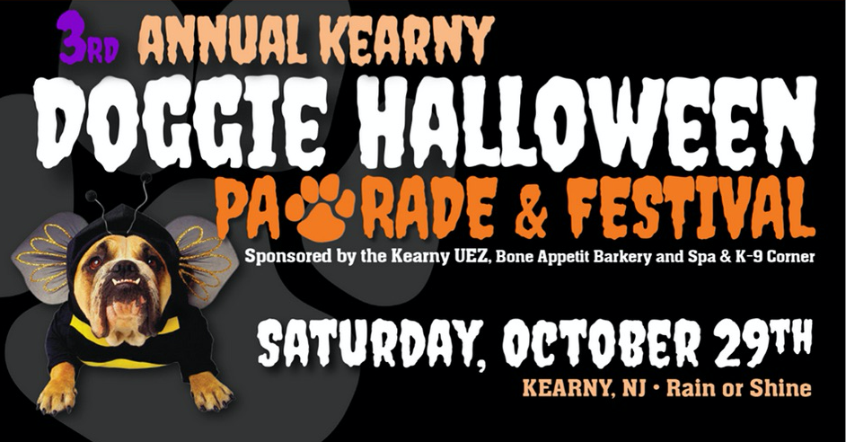 REGISTRATION

**(LAST DAY TO PRE REGISTER IS Thursday, Oct. 27, 3 p.m.)**

*(Please print clearly)*

DOG OWNER’S NAME: ___________________________________________

PHONE: ( ) __________________ EMAIL: _________________________

STREET ADDRESS: _______________________________________________

CITY: ___________________________ STATE: ______ ZIP: ______________

*AS LEGAL OWNER, I CERTIFY MY DOG IS NOT A HAZARD TO PEOPLE OR OTHER DOGS, AND IS CURRENT*

*IN ALL VACCINATIONS. I AGREE TO ABIDE BY THE RULES LISTED ON THIS FORM AND TO COMPLY WITH ANY HEALTH/MEDICAL/SAFETY RECOMMENDATIONS MADE BY EVENT OFFICIALS.*

***!!COPIES of PROOF of CURRENT LICENSE and UP-TO-DATE RABIES VACCINE DOCUMENTATION***

***MUST BE PROVIDED with this completed REGISTRATION form!!***

DOG OWNER SIGN HERE: _____________________________________________________(MUST BE 18 YEARS OR OLDER)

***(Dog walkers at the event must also be 18 years or older)***

DOG NAME: __________________________________

DOG BREED/MIX: _____________________________DOG WEIGHT_________________

MY DOG (AND I) WOULD LIKE TO COMPETE IN THE FOLLOWING CONTEST (CHOOSE ONLY 1 CONTEST):

**GROUP A/ DOGS UNDER 40 POUNDS**

DOG COSTUME ONLY _____ DOG/OWNER COSTUME_____

**GROUP B/ DOGS OVER 40 POUNDS**

DOG COSTUME ONLY_____ DOG/OWNER COSTUME_____

DROP OFF THESE FORMS AT either the KUEZ Office, 410 Kearny Avenue, K9 Corner, 169 Midland Avenue, or

email [Pawrade@kearnynj.org](mailto:Pawrade@kearnynj.org) / fax 201-955-1827 (***must include scan/copy up-to date rabies /license docs***)

***PICK UP YOUR CONTEST ENTRY NUMBER at the REGISTRATION TABLE THE DAY OF EVENT***

**WITH YOUR REGISTRATION RECEIPT the day of the PAWRADE (10 a.m. to 11:30 a.m.)**

WAIVER and RELEASE OF LIABILITY

**OWNER INFORMATION**

OWNER NAME: ___________________ ____________ **DOG** NAME: ____________________

IN CONSIDERATION OF BEING ALLOWED TO PARTICIPATE IN ANY WAY IN **THE 2016 KEARNY HALLOWEEN DOG PARADE & FESTIVAL** PROGRAM, RELATED EVENTS AND ACTIVITIES, WHICH WILL TAKE PLACE AT Arlington Depot Park, Kearny, NJ on Saturday, October 29th, THE UNDERSIGNED ACKNOWLEDGES, APPRECIATES, AND AGREES THAT:

1) MY VOLUNTARY PARTICIPATION IN THIS EVENT MAY RESULT IN PERSONAL INJURY TO ME AND/OR MY ABOVE MENTIONED DOG (“DOG”), AND THAT THE RISK OF INJURY FROM THE ACTIVITIES INVOLVED IN THIS PROGRAM EXISTS.

2) BY PARTICIPATING IN, ATTENDING AND/OR OBSERVING THE EVENT I KNOWINGLY AND FREELY ASSUME ALL SUCH RISKS, BOTH KNOWN AND UNKNOWN, THAT ARE INCIDENTAL TO OR IN ANY WAY ARISE FROM THE CONTEST, INCLUDING, WITHOUT LIMITATION, ALL RISKS AND DANGER INHERENT IN A CANINE-ORIENTED EVENT (E.G., DOG BITES, FIGHTS OR ALTERCATIONS, FALLS, CONTACT WITH SPECTATORS AT THE CONTEST), EVEN IF ARISING FROM THE NEGLIGENCE OF THE RELEASEES OR OTHERS, AND ASSUME FULL RESPONSIBILITY FOR MY PARTICIPATION;

3) I ACCEPT FULL RESPONSIBILITY FOR ANY AND ALL ACTIONS OF THE DOG AND AGREE THAT THE DOG WILL BE IN MY CARE AND CONTROL DURING THE CONTEST; I AM ALSO RESPONSIBLE FOR REMOVING MY DOG’S LITTER.

4) I UNDERSTAND AND ACKNOWLEDGE THAT DOG MUST HAVE A COLLAR AND A LEASH MUST BE ON HAND BY OWNER/PARTICIPANT, AND THAT THERE IS A ONE DOG LIMIT PER HANDLER. ALL DOG WALKERS AT THE EVENT MUST BE 18 YEARS OR OLDER.

5) I HEREBY REPRESENT AND CONFIRM THAT THE DOG IS NOT SUBJECT OF A QUARANTINE ORDER, A PENDING ADJUDICATION OR ADMINISTRATIVE HEARING, AND HAS NEVER BEEN DECLARED DANGEROUS, POTENTIALLY DANGEROUS OR VICIOUS OR POTENTIALLY VICIOUS DOG;

6) I WILLINGLY AGREE TO COMPLY WITH THE STATED AND CUSTOMARY TERMS AND CONDITIONS FOR PARTICIPATION, AND TO ABIDE BY ALL APPLICABLE GOVERNMENTAL LAWS, ORDINANCES, ORDERS, DIRECTIONS, RULES AND REGULATION. IF, HOWEVER, I OBSERVE ANY UNUSUAL SIGNIFICANT HAZARD DURING MY PRESENCE OR PARTICIPATION, I WILL REMOVE MYSELF AND/OR THE ABOVE MENTIONED DOG FROM PARTICIPATION AND BRING SUCH TO THE ATTENTION OF THE NEAREST OFFICIAL IMMEDIATELY;

7) I ACKNOWLEDGE THAT the KEARNY URBAN ENTERPRISE ZONE, TOWN OF KEARNY and its AGENTS RESERVES THE RIGHT TO EXCLUDE OR EJECT ANY AND ALL UNRULY, ROWDY OR DISRUPTIVE OWNERS/PARTICIPANTS AND/OR DOGS FROM THE CONTEST AND/OR FROM THE PROPERTY WITHOUT LIABILITY AND THAT I SHALL BE FULLY RESPONSIBLE FOR ANY DAMAGES OR EXPENSES, DIRECT OR INDIRECT, INCURRED AS A RESULT OF ME OR MY DOG/S DISRUPTIVE BEHAVIOR AND /OR EJECTION. I FURTHER AGREE THAT ANY OFFICIAL MAY AUTHORIZE NECESSARY TREATMENT FOR ME AND/OR THE DOG IN THE EVENT OF INJURY;

8) I FURTHER AGREE TO ASSUME LIABILITY FOR ANY AND ALL MEDICAL COSTS INCURRED AS A RESULT OF MY PARTICIPATION TO THE CONTEST THAT ARE NOT COVERED BY MY INSURANCE, INCLUDING BUT NOT LIMITED TO COSTS OF MEDICAL CARE AND TREATMENT, AMBULANCE SERVICES, HOSPITAL STAYS, AND PHYSICIAN TREATMENT.

9) I, or my assigns, will not hold **the TOWN OF KEARNY, KEARNY URBAN ENTERPRISE ZONE, BONE APPETIT and/or K9 CORNER** THEIR OFFICERS, OFFICIALS, AGENTS, AND/OR EMPLOYEES, OTHER PARTICIPANTS, SPONSORING AGENCIES, SPONSORS, ADVERTISERS, AND IF APPLICABLE, OWNERS AND LESSORS OF PREMISES USED TO CONDUCT THE EVENT (“RELEASEES”), WITH RESPECT TO ANY AND ALL INJURY, DISABILITY, DEATH, OR LOSS OR DAMAGE TO PERSON OR PROPERTY, WHETHER ARISING FROM THE NEGLIGENCE OF THE RELEASEES OR OTHERWISE, TO THE FULLEST EXTENT PERMITTED BY LAW.

I HAVE READ THIS RELEASE OF LIABILITY AND ASSUMPTION OF RISK AGREEMENT, FULLY UNDERSTAND ITS TERMS, UNDERSTAND THAT I HAVE GIVEN UP SUBSTANTIAL RIGHTS BY SIGNING IT, AND SIGN IT FREELY AND VOLUNTARILY WITHOUT ANY INDUCEMENT.

SIGNED: _____________________________________________ DATE: ____________________ *(PARTICIPANT'S/DOG OWNER SIGNATURE – must be 18 years or older)*



RECEIPT OF REGISTRATION

***BRING this RECEIPT WITH YOU the DAY of the EVENT***

***PICK UP YOUR PARADE NUMBER AT THE REGISTRATION TABLE***

***(Open from 10 a.m. – 11:30 a.m.)***

*The Care Of Our Furry Friends Is Always Our First Priority!* In The Interest Of All Participants, Please Abide By The Following Rules:

* ALL DOGS MUST REMAIN LEASHED.
* RABIES SHOTS AND VACCINATIONS MUST BE CURRENT.
* MAXIMUM OF ONE DOG PER HANDLER; DOGS MUST WEAR I. D. TAGS AT ALL TIMES.
* ALL DOG WALKERS MUST BE 18 YEARS OR OLDER.
* NO DOGS IN HEAT.
* NO AGGRESSIVE DOGS.
* DOG WALKERS/OWNERS ARE RESPONSIBLE FOR REMOVING THEIR DOG’S LITTER (through use of a pooper scooper or litter bag.)
* COSTUMES MUST BE SAFE, COOL AND COMFORTABLE FOR DOGS.
* ALL PARTICIPANTS MUST COMPLY WITH ANY HEALTH/MEDICAL/SAFETY RECOMMENDATIONS MADE BY EVENT OFFICIALS.

**EVENT OFFICIALS MAY DISQUALIFY OR REMOVE ANY ENTRY FOR VIOLATING ANY OF THESE RULES**

**NAME _____________________________________________________________________________**

**DOG NAME____________________________________________**

**(To be filled out by PAWRADE staff day of event) REG COMPLETE _______ INITIALS ______**